**Machine Learning Project**

Objective – ML model to detect PPE equipment on real-time video data and generate triggers for action to ensure safety of personnel at plant site

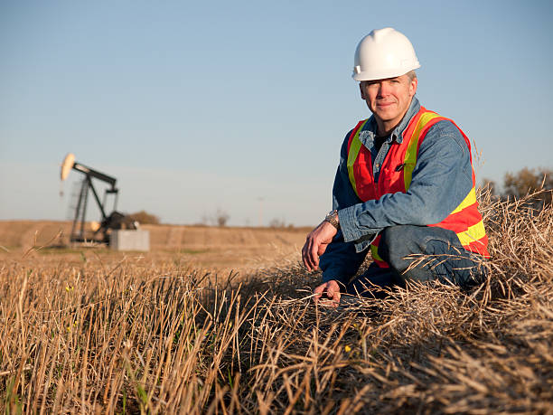

Saftey Vest

Saftey Hat

*Istockphoto.com*

Saftey Hat

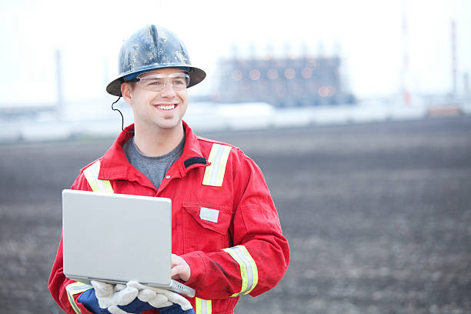

Saftey goggles

References

============================================================

For labeling object - https://github.com/heartexlabs/labelImg

Detect PPE equipment - https://towardsdatascience.com/using-yolov3-for-real-time-detection-of-ppe-and-fire-1c671fcc0f0e